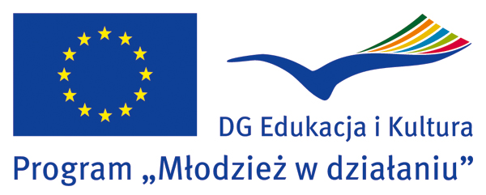 |  |  |  |  | Wniosek o przyznanie statusu akredytowanej organizacji EVS w ramach Programu  „Młodzież w Działaniu”
Formularz Rejestracyjny nr
(wypełnia Narodowa Agencja)
Niniejszy wniosek dotyczy działań w ramach Akcji:
Akcja 2 – Wolontariat Europejski – LIST INTENCYJNY

Organizacja
Nowa akredytacja
Powtórna akredytacja. Poprzedni numer EI:
Dane organizacji
Nazwa | Fundacja Integracji Społecznej „Prom”
Ulica | ul. Szczepińska 2/16 (siedziba) / pl.Solidarności 1/3/5 Wrocław 53-661 (biuro)
Kod pocztowy | 53-655 | Miejscowość | Wrocław
Województwo | Dolnośląskie | Kraj | Polska
E-mail | biuro@fundacjaprom.pl | Strona www | fundacjaprom.pl
Telefon | 071-3592921 | Fax | 071-3592921

Przed wysłaniem Listu Intencyjnego do Narodowej Agencji raz jeszcze sprawdź:
Czy wypełniłeś/aś wniosek w języku angielskim? Wersja polska Listu Intencyjnego ze wskazówkami znajduje się na stronie: http://www.mlodziez.org.pl/index.php/ida/886/
Czy wypełniłeś wszystkie pola związane ze statusem, o który się ubiegasz?
Czy przedstawiciel prawny organizacji podpisał wniosek w części IV?
Czy wysłałeś wniosek do Narodowej Agencji także w wersji elektronicznej (na adres e-mail: ei@frse.org.pl)?
Czy załączyłeś/aś aktualny statut organizacji?
Czy załączyłeś/aś do wniosku aktualny (wystawiony nie wcześniej niż 3 miesiące przed
najbliższym terminem składania wniosków do programu „Młodzież w działaniu”) wyciąg
z Krajowego Rejestru Sądowego?

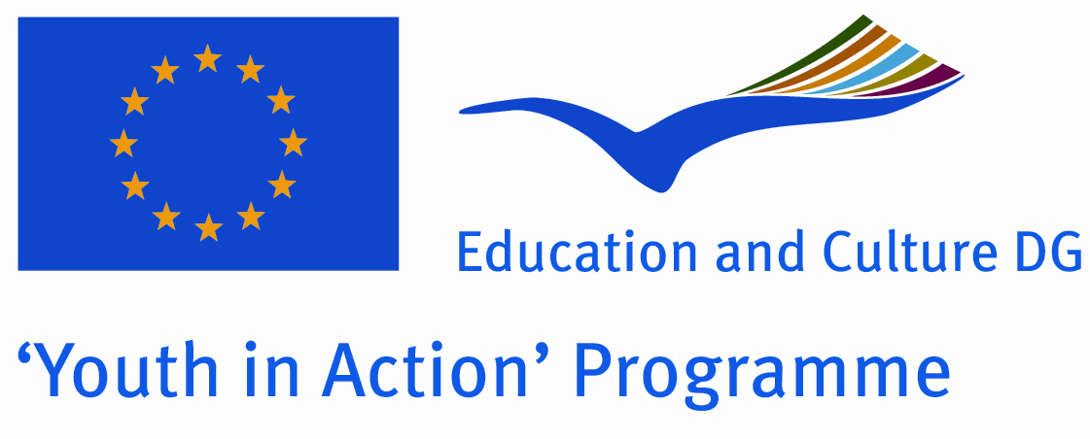 |  |  |  |  | Expression of Interest  Action 2 - European Voluntary Service  Version valid as of 1 January 2009
Please fill in all relevant sections of this form. It is compulsory to annex ALL documents requested in the check list.
Please consult the Programme Guide to find all the information you need to fill in this form.

Part I. Accreditation context
Reference number
To be filled in by the National Agency, the Executive Agency or SALTO SEE Resource Centre |  |  |  |  |  | Postmark/Date of receipt
Name of the organisation
Please indicate the name and acronym of the organisation. |  |  |  |  |  | Foundation of Social Integration - Prom
Type of accreditation
Please tick the box(es) corresponding to the type of accreditation requested.
Sending Organisation Host Organisation Coordinating Organisation
Validity of the Expression of Interest
Please tick one box only.
This Expression of Interest should be valid for the maximum period of 3 years after approval.
This Expression of Interest should not be valid after (specify date up to 3 years):
Profile of the organisation
Type and status | Non profit/non governmental organisation  International governmental organisation  Body active at European level in the field of youth |  |  |  |  |  |  |  | Public body  Profit-making organisation¹  Other – please specify:
Activity level | local |  |  | regional |  |  | national |  |  |  |  | European/international
¹ Only when it organises an event in the area of youth, sport or culture.

Motivation and EVS experience
Please describe the motivation of your organisation to participate in European Voluntary Service as well as your current or previous involvement in EVS (including the approximate starting date and the frequency of your involvement).
We want participate on EVS hosting projects this was one of our aims since a while. We do not have experience with EVS projects but we host volunteers and students making scholarship from our city very often. Our drop in centres are regular practice place for pedagogy and psychology students.
Other motivations:
- to develop the social relations of the people in our care,
- to give opportunity to learn about other cultures,
- to motivate them with benefits of learning a foreign language, personal development,
- to boost self confidence and make them believe they can achieve a lot,
- to gain new skills and invaluable experiences,
- to increase activity of the Foundation (intercultural experience).
Part II. Details of the organisation
Name |  |  | Foundation of Social Integration - Prom
Street address |  |  | ul. Szczepińska 2/16, (office: pl.Solidarności 1/3/5 Wrocław 53-661)
Postcode |  |  | 53-655 |  |  |  |  | City |  | Wroclaw
Region |  |  | Lower Silesia |  |  |  |  | Country |  | Poland
Email |  |  | biuro@fundacjaprom.pl |  |  |  |  | Website |  | fundacjaprom.pl
Telephone |  |  | 071-359 29 21 |  |  |  |  | Telefax |  | 071-359 29 21
Legal representative
Family name (Mr/Ms) |  |  | Balkowski |  |  |  |  | First name |  | Janusz
Position/function |  |  | President
Family name (Mr/Ms) |  |  | Czuba |  |  |  |  | First name |  |  | Paweł
Position/function |  |  | treasurer
Family name (Mr/Ms)
Position/function |  |  | Swietanowska |  |  |  |  | First name |  | Anna
Position/function |  |  | Drop in Center Coordinator
Email |  |  | ania@fundacjaprom.pl
Telephone |  |  | 071 359 29 21 |  |  |  |  | Telefax |  | 071 359 29 21
Contact point for EVS outside the organisation
Family name (Mr/Ms) |  |  |  |  |  |  |  | First name
Organisation
Street address
Postcode |  |  |  |  |  |  |  | City
Region |  |  |  |  |  |  |  | Country
Email |  |  |  |  |  |  |  | Website
Telephone |  |  |  |  |  |  |  | Telefax
Description of the organisation
Please present briefly your aims and regular activities. Add information about the staff of your organisation as well as the target group you generally work with.

Who we are:

Foundation of Social Integration -Prom is a non-governmental organization established in March 2004, composed of persons interesting in coming with conscious and effective aid. It forms an association of educational workers, teachers, cultural animators, therapists, students and voluntary workers.

Who we help:
Being obliged to act for the common good, the Foundation chose as its main goal the help for the most needful people, integration and activation of different environments, including social groups discriminated against, marginalized and those endangered by the risk of social exclusion.
The beneficiaries of our actions are children and young people from large families, families endangered by unemployment and threatened by pathologies, national minorities (particularly Romani people), the unemployed and the poorest urban inhabitants, disabled persons, including mentally ill.

How we help:
1.We run four drop in centres for children and young people based in different district of City Wroclaw. One of them integrational for Romany children based in the city centre. With full teaching and supporting programme (help in learning, foreign language classes, dance courses, model-making, artistic and sports activities, feeding, speech - therapy aid and psychological assistance),
2. We organize summer camps, day camps and winter holidays for our charges,
3. We participate in arrangement of clubs for children, organize financial help, we have our programme web page on the Internet (www.fundacjaprom.pl), we organize artistic competitions with Romani subject matter, Reviews of Young Romani Talents, integrating summer camps for Romani and Polish children, training courses and conferences.
4. We run four social and legal advice centres on the territory of Wrocław,
5. We organize different kinds of integrating events for all beneficiaries.
Who supports us:
Our activities are financially supported by the City Wrocław Council, Lower Silesian Governor’s Office, Ministry of Interior and Administration, Ministry of Culture, Danone Poland, The Fund of Environmental Protection, Batory Foundation, The Fund for Disabled Persons, EEA and Norway Grants.
More information’s: www.fundacjaprom.pl

Part III. Ideas for future EVS Activities
Main themes for the Activities:
Please tick not more than 2 boxes.
European awareness | Post conflict/post-disaster rehabilitation
Inter-religious dialogue | Urban/Rural development
Anti-discrimination | Youth policies
Art and culture | Media and communications/Youth information
Disability | Education through sport and outdoor activities
Minorities | Health
Gender equality | Environment
Civil Protection | Development Cooperation
Non-discrimination based on sexual orientation | Roma communities
Other - If so, please specify: Equation to opportunities

Inclusion of young volunteers with fewer opportunities:
Do you envisage involving young people with fewer opportunities (facing a situation that makes their inclusion in society more difficult, see main situations/obstacles identified here below) and/or special needs (mobility problems, health care, etc.)? If so, please tick the situation(s) they may face:
Social obstacles | Economic obstacles | Disability
Educational difficulties | Cultural differences | Health problems
Geographical obstacles | Other – please specify:

Expected duration and type of EVS:
Please tick one or more boxes corresponding to the duration and type of the EVS Service(s) you plan to send/host/coordinate:
6 to 12 months
2 to 5 months
2 weeks to 2 months (involving young people with fewer opportunities)
2 weeks to 2 months (Group EVS involving at least 10 volunteers)

Part IV. Host Organisation
This part has to be filled in only if the applicant requests to be accredited as Host Organisation. The points below are intended to serve as a guide for the description of activities foreseen by the Host Organisations.
If more space is needed, please extend boxes.

Project environment:
Outline the project environment for the suggested voluntary activities, including the local community where the project will take place (e.g. geographical, social and economical environment). If the host placement is located in a live-in community, please include the rules and conditions that apply also for the volunteer.

Our organization is located in Wrocław – a very open and cosmopolitan city for young people, full of students.
We cooperate with teachers, psychologists, art therapist, trainers, dance instructors, lawyers, students and other non-governmental organizations.
The main goal of the Foundation “Prom” is to integrate and support people from disadvantaged backgrounds; to enable them to participate in educational and cultural events; to promote them in society; to fight against discrimination, intolerance and lack of acceptance towards the most helpless groups in Poland ( the poorest, unemployed, national minorities).
The major need is to break off the negative stereotypes and know each other by acting together.
We work with children , youth and adults from poor and pathological families (we have four drop in centres (working afternoons) for children and youth. We take care of them, organize artistic and sports activities, excursions, summer and winter holidays, we offer a chance for them to develop their interests, artistic skills and enhance educational possibilities.
We provide the poorest with food, give legal advice free of charge , learn about social issues and human rights, we have great experience in work with Romani Community from Wroclaw. We cooperate with Romani Bacht Association, we participated in international study tours to Romani Associations from Czech and Slovakia, recently we published book:”Education of Romani people in Central Europe” and picture story about Romani History.

Proposed activities for EVS volunteers:
Please explain:
- what you can offer to volunteers in terms of Service and learning opportunities,
- what will be the role of EVS volunteers in the Host Organisation,
- the activities in which the volunteers could be involved and the activities the volunteers could create in your organisation. Please give examples of typical activities for the volunteers.

We let volunteers work with us, share our experience and give them new skills and possibilities, which will enhance and influence their future careers.
The volunteer will gain vast knowledge about daily life of a non-governmental organization and experiences in working with children, youth and adults from disadvantaged backgrounds.
Proposed activities:
- observation of specialists from many professions-teachers, psychologists, lawyers (in the drop in centre for children and youngsters, schools, club for mentally ill, Tourist Office of Foundation Prom, free Legal Advice Offices organized by Foundation).
- participation in artistic and sports activities,
- taking part in educational projects,
- helping staff preparing workshops and preparing own activities for our charges, organizing their free time for them, organizing meetings promoting culture and language of volunteer.
- helping to organize international meetings, conferences, study tours held as part of Romani Programme.
- participation in sightseeing tours to get know better region of Lower Silesia and other parts of Poland.
-participation in winter and summer camps form youth and children.

One of the tasks for the volunteer could be to establish contacts with similar organization in his/ her home country in order to have mutually beneficial and interesting co-operation between them in future (programs of youth exchanges, etc ).
Another task of volunteer is to increase international awareness amongst young people, promoting the general idea of voluntary as powerful tool of non-formal education.
Free time activities: learning Polish, touring, going out with students who are studying in Wrocław or with other international volunteers.

Volunteer will have 2 days off every week which will normally be on the weekend although some weekend work will be necessary If so, the days off can be rearranged to be taken during the week.
A typical day could look like the following: 9:00 - 12:00 office work or language course (there will be possibility to work in club for people with mental problems), lunch brake,15:00-19:00 work in drop in centre with youth and children.
Some Saturdays participation in excursions.
During summer, winter holidays participation in youth/ children camps.
The working hours will be around 35 hour a week. 50% of this time volunteer will work in drop in centers and other 50% he/she can choose office work or work with people with mental problems. This will depend on volunteer interests.

Volunteer profiles and recruitment process:
Please describe the profiles of volunteers you would like to receive in your organisation. Include information on how you ensure an open and transparent recruitment process as well as the overall accessibility of EVS to all young people. Consider further information about the type of Sending Organisation you want to cooperate with. This information can help the match-making between volunteer candidates, Sending Organisations and your organisation.
We would like to invite into Wroclaw:
- people interested in pedagogy, psychology, social work in a big city,
- people interested in Romani culture, history and current issues,
- creative and imaginative people,
- positive, open minded, honest,
- flexible, friendly, helpful and warm-hearted,
- able to work on own initiative,
- motivated and interested in working with teenagers, children, minorities,
- responsible and reliable,
- able to work on his/her own initiative.
Information’s about possibility of work experience in our Foundation we place in the Internet.
We would like to cooperate with Sending Organization which has similar objectives to ours but we will stay open for something new as well.

Number of volunteers hosted:
Please state the maximum number of volunteers your organisation is able to host at the same time (ensuring all quality, learning, and welfare standards of EVS for each volunteer):
We would like to host two volunteers.

Special needs (if applicable):
If your placements are open to hosting volunteers with fewer opportunities, please provide information about the competence, experience and infrastructure and (human or other) resources available in your organisation to accommodate and support them.
We open to host volunteers with fewer opportunities especially those who face economic obstacles and cultural differences. As our beneficiaries face the same problem we have good experience and staff trained to work with such group.
Volunteer will get support and assistance from our organization members and psychology help if needed.

Risk prevention, protection and safety:
Please describe:
- how you will guarantee a safe living and working environment for the EVS volunteers,
- how you will prevent risks and crises,
- how – in the case of EVS volunteers aged 16 or 17 – you ensure appropriate supervision, protection and safety.
- volunteer work is safe and been assessed for risk.
- every effort is made that project meets high health and safety standards
- volunteer will be trained and familiar with the health and safety policies in our organisation and have access to adequate safety equipment if needed
- volunteer will get all the practical and psychological support from the staff and his future mentor, will have regular supervisions.
- we will stay in touch with sending organization to solve occurring problems.
We do not plan to host volunteers under age 18 because in our drop in centres we can have only volunteers age 18+ (legal requirements).

Part V. Signature
I, the undersigned, certify that all information contained in this Expression of Interest is truthful and accurate and that no relevant information has been withheld.
I declare to be aware of the provisions set out in the EVS Charter and I undertake to adhere to them in case the organisation I represent will be accredited within the EVS context.
By signing this document the promoter authorises the European Commission, the Executive Agency and the National Agency to publish and to use all data provided in this Expression of Interest in any form and medium, including the Internet database of accredited organisations. The data, on paper or electronically, will always be used respecting the privacy of individual persons. In case of approval, the accreditation will have a validity of three years unless a shorter validity period has been indicated. The promoter undertakes to inform of all changes related to this accreditation.
For the organisation
Name of the organisation: |  | FUNDACJA INTEGRACJI SPOŁECZNEJ - PROM / FOUNDATION OF SOCIAL INTEGRATION - PROM
Name of the legal representative in capital letters: |  | JANUSZ BALKOWSKI
Position/function: |  | PRESIDENT
Name of the legal representative in capital letters |  | PAWEŁ CZUBA
Position/function: |  | TREASURER
Place, date: | WROCLAW, 29.01.2009 | Signature:
Place, date: | WROCLAW, 29.01.2009 | Signature:

